**Code Refactoring and Bug Fixing**



**About me**

**In summary, my name is B. Prasanna Lakshmi, and I am a passionate data science graduate with a keen interest in leveraging data to solve complex problems and drive business innovation. I chose to pursue a career in data science due to its high demand, promising growth opportunities, and the diverse range of job prospects available across various industries. I am excited to apply my skills and knowledge to make meaningful contributions in the field of data science and contribute to driving positive change in organizations.**

**Bugs Identified:**

1. Template Not Found Error**: The Flask application is unable to locate the HTML template file.**
2. Form Submission Issue**: The form submission logic is incorrect, causing notes not to be added properly.**
3. Incorrect Method for Retrieving Form Data**:** request.form.get() **should be used instead of** request.args.get() **for retrieving form data.**

**Bug Fixes:**

* **Template Not Found Error:**

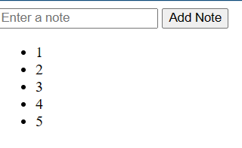**Issue:** The HTML template file (home.html) is not in the correct directory (templates).

**Solution:** Move the home.html file to the templates directory.

* **Form Submission Issue:**

**Issue:** The form submission logic does not properly handle POST requests and append notes to the notes list.

**Solution:** Refactor the form submission logic to handle POST requests and append notes correctly.

* **Incorrect Method for Retrieving Form Data:**

**Issue:** request.args.get() is used to retrieve form data from the POST request, which is incorrect.

**Solution:** Use request.form.get() instead to properly retrieve form data from the POST request.

**Fixing Flask Code Implementation**

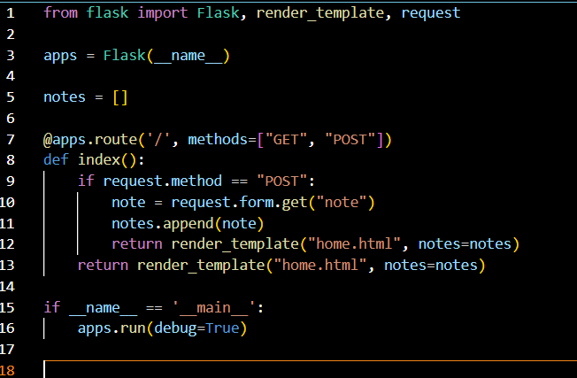

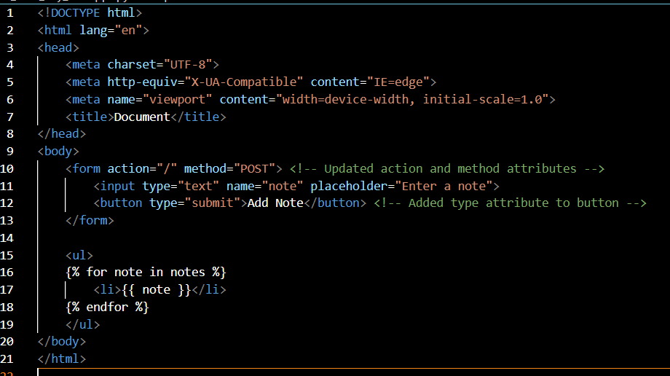**HTML CODE FIXING**

**Bug Fix Report:**

1. **Template Not Found Error:** The HTML template file (**home.html**) was not located in the correct directory (**templates**). Moved the **home.html** file to the **templates** directory to resolve the issue.
2. **Form Submission Issue:** Refactored the form submission logic to properly handle the POST request and append notes to the **notes** list.
3. **Incorrect Method for Retrieving Form Data:** Used **request.form.get()** instead of **request.args.get()** to retrieve form data from the POST request.

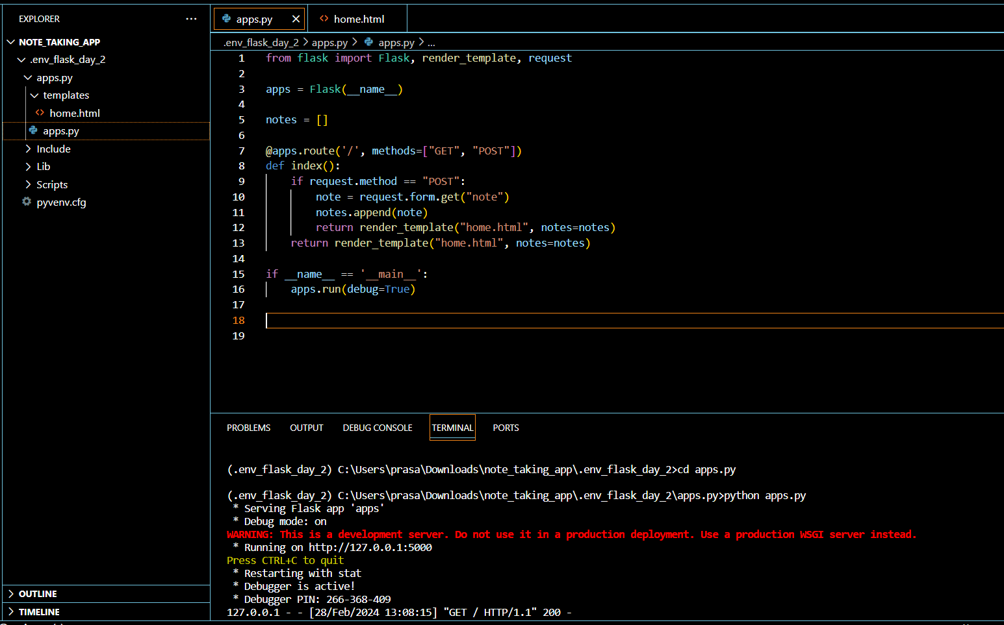



# **THANK YOU**